***Penfolds Bin 144 Yattarna Chardonnay***

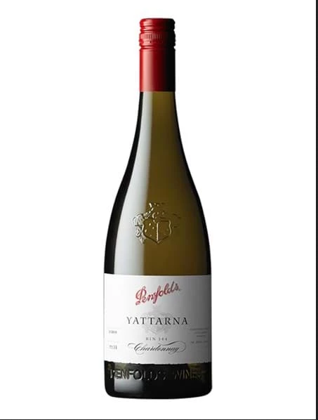

*Penfolds Bin 144 Yattarna Chardonnay Premium White Wine - Chardonnay grapes are harvested from vineyards in Tasmania, Tumbarumba and the Adelaide Hills, Australia. After fermentation, the wine is aged for 8 months in French oak barrels.*